6.76: a) Equating the work done by the spring to the gain in kinetic energy, 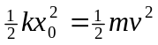, so
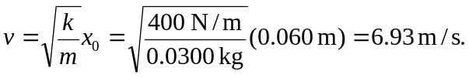
b) 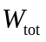 must now include friction, so 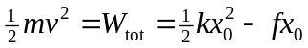, where f is the magnitude of the friction force. Then,
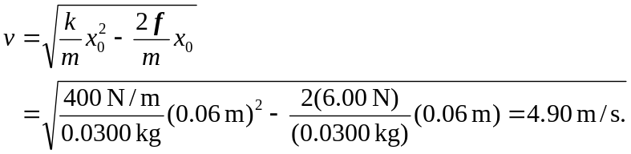
c) The greatest speed occurs when the acceleration (and the net force) are zero, or 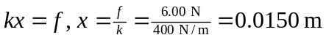. To find the speed, the net work is 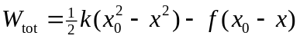, so the maximum speed is
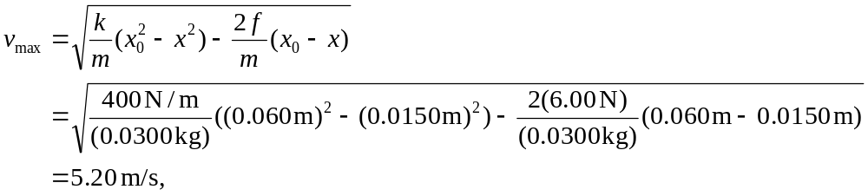
which is larger than the result of part (b) but smaller than the result of part (a).

